QA Test Document – Reports Reference Management System (Oracle APEX)
Date: 11/06/2026
Reviewed By: Yara Yasin

1. Overview
A reporting management system was developed using Oracle APEX.
The system maintains a reference table containing report information including the report name, report description, and the associated database view used for data extraction.
This functionality helps document reports, simplify maintenance activities, and provide a centralized repository for report metadata.
http://192.168.10.123/

2. Objective
To verify that the reports reference management system functions correctly by validating data entry, report information retrieval, update operations, and ensuring the integrity of the stored report metadata.

3.System Description
The system was developed using Oracle APEX to provide users with an efficient and user-friendly reporting platform.
A reference table was also created to maintain report metadata, including:
- Report Name
- Report Description
- Associated Database View
This approach was implemented to ensure proper documentation of all reports, facilitate report management, simplify maintenance activities, and improve traceability of the data sources used for report generation.

4. Test Scenarios

TC-001: Verify login page loads successfully
Expected Result:
- Login page is displayed correctly without errors

TC-002:
Verify page title is displayed
Expected Result:
- "yara's report" appears correctly

TC-003: Verify user image/logo is displayed
Expected Result:
- Image is visible without distortion

TC-004: Verify Username field is displayed
Expected Result:
- Username textbox is visible and enabled

TC-005: Verify Password field is displayed
Expected Result:
- Password textbox is visible and enabled

TC-006: Verify Sign In button is displayed
Expected Result:
- Button is visible and clickable

TC-007:Verify Remember Username checkbox is displayed
Expected Result:
- Checkbox is visible and selectable

TC-008: Verify hide password functionality
Expected Result:
- Password becomes masked again

TC-009: Verify password is masked by default
Expected Result:
- Password characters appear as dots/bullets

TC-010: Verify show password icon functionality
Expected Result:
- Password becomes visible when the icon is clicked.

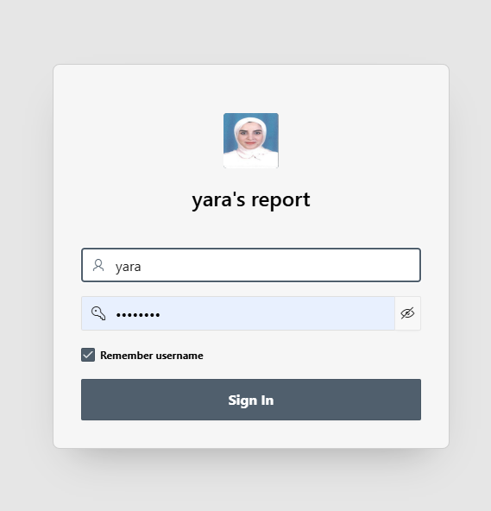
—------------------------------------------------------------------------------------------------------------------------

5. Reports Dashboard
The Reports Dashboard is an Oracle APEX module that provides users with access to financial reports through interactive tiles.
The dashboard is divided into two main sections:
Daily Reports
Monthly Reports
Each tile represents a specific report and redirects the user to a dedicated report page with applied filters such as date range and business rules.

6. Modules Breakdown
A) Daily Reports
This section includes operational financial reports such as:
Outgoing Transactions Report
Incoming Transactions Report
Cheque Deposits Report
Outgoing Transfers Report
ATM / Mobile Withdrawals
Other ATM/Mobile Operations
Financial Center Transactions Report

B) Monthly Reports
This section includes analytical and compliance reports such as:
High-Risk Countries Report
Customer Data Report (Digital ID & Bank Account Linking)
Green Line Workers Report

7. Functional Test Cases
TC-01: Dashboard Access
Expected Result:
Dashboard loads successfully
All report tiles are displayed correctly without errors

TC-02: Open Report from Tile
Expected Result:
User is redirected to the correct report page
Page loads successfully (HTTP 200)
Correct report title is displayed

TC-03: User Authorization
Expected Result:
Only authorized reports are visible
Unauthorized tiles are hidden or disabled

TC-04: Performance Test
Expected Result:
Report loads within acceptable time (≤ 3–5 seconds)
No timeout or system freeze occurs

TC-10: Direct URL Access (Security Test Cases)
Expected Result:
User is redirected to login page
